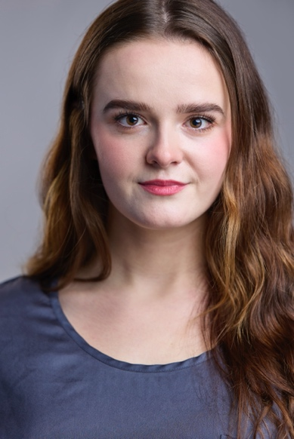
Julietta Guinasso

juliettaguinasso@outlook.com HEIGHT- 5’ 4”
(425)-246-5890 HAIR/EYES- BROWN
juliettaguinasso.com RANGE- MEZZO

THEATRE

SOMETHING ROTTEN! Bea University of Northern Colorado

HEATHERS Veronica Sawyer ArtsWest
Dir. Jay Santos
BIRTHRITE* Child Equity Library Stream

TO KILL A MOCKINGBIRD Mayella Ewell Renton Civic Theatre

SILENT TREATMENT Mediator New Work Series at MCS

SANS MERCI Kelly University of Northern Colorado

ON THE TOWN Madame Dilly University of Northern Colorado

ALMOST MAINE Lendall and Ginette University of Northern Colorado

*World Premier of BIRTHRITE, a new work being streamed through Equity Library

TRAINING
Bachelor of Arts Ryan Driscoll University of Northern Colorado
Musical Theatre (c/o 2022)
Minor in Dance Monte Black

Singing: Colten Blair, Ryan Driscoll
Acting: Matthew Corozine, Ryan Driscoll, Rebecca Rich Joy, Aaron Galligan-Stierle, Rachel Hoffman
Dance: Monte Black, Christy Black, Kimberly Clay, John Leonard, Jill Kenney

SKILLS
Beginner guitar, Beginner piano; Intermediate British dialect, Beginning Irish dialect, Intermediate southern dialect; Passport; Great with kids; Weight lifting; Botanist; Frog noise.

